Introduction to Test Automation with REST Assured

Installation guide

# Postman installation

1.Go to page <https://www.postman.com/downloads/>

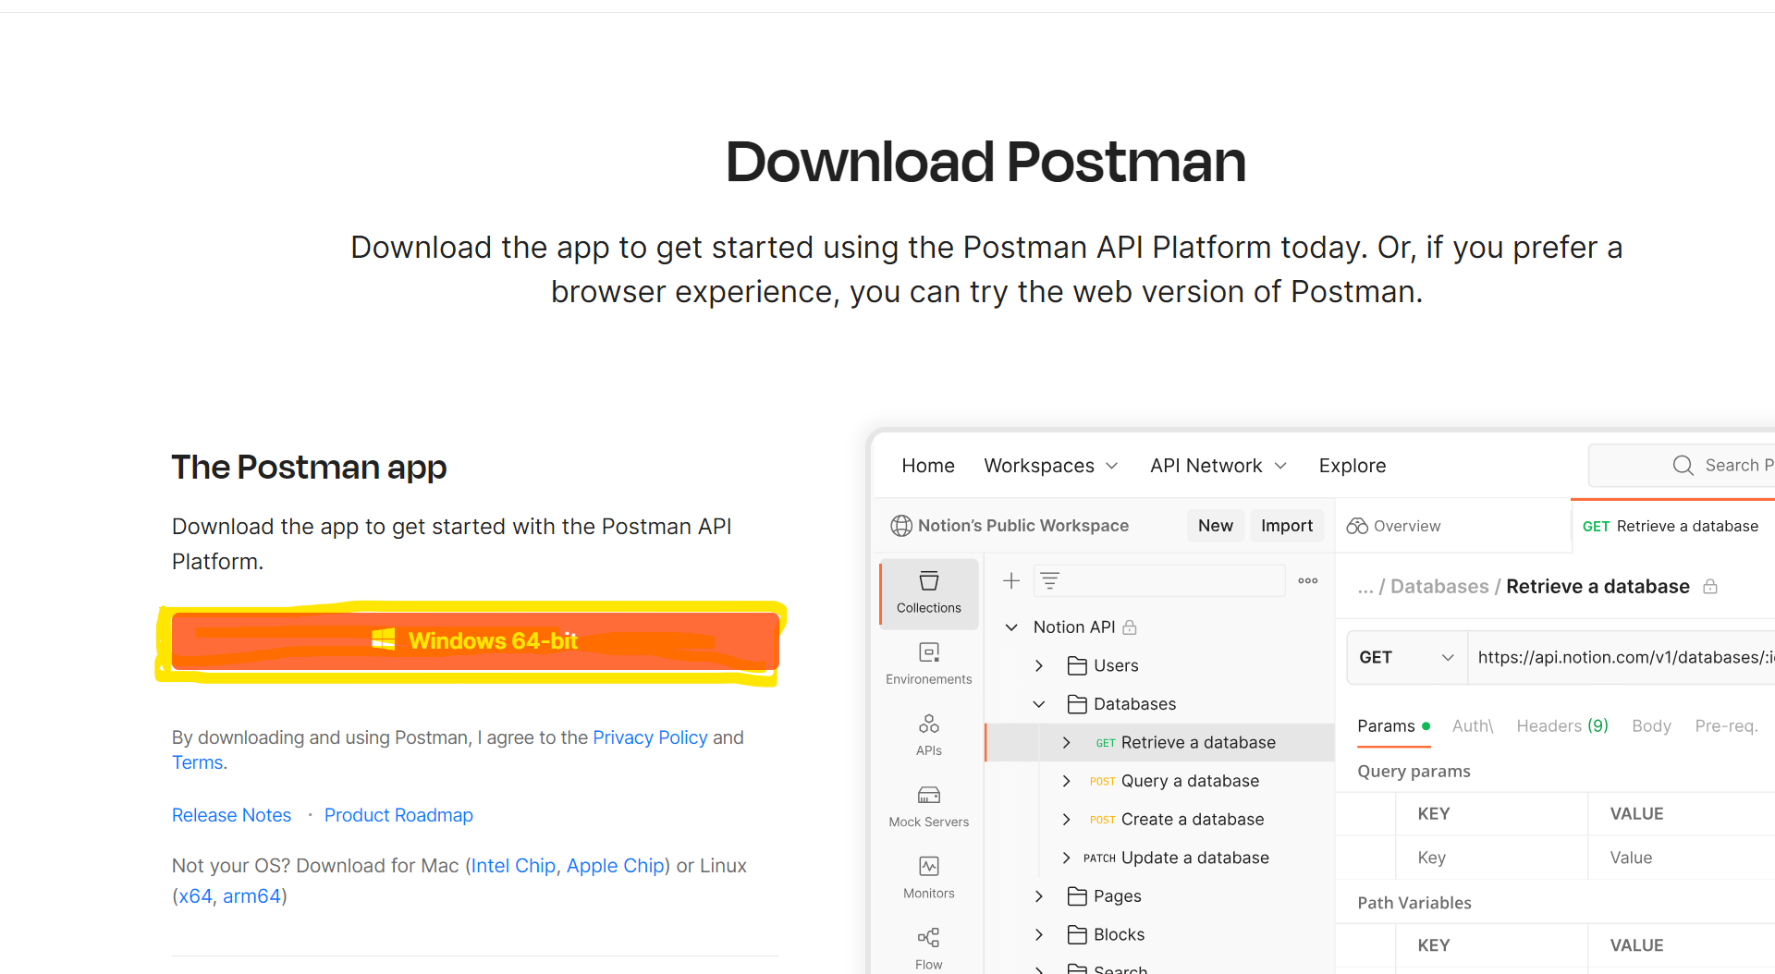

Figure 1 Postman Download page

2.Press “**Windows 64-bit**” button to download installer file.

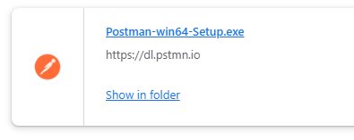

Figure 2 Downloaded Postman installer

3.Open downloaded installer. Postman will install on your computer automatically.

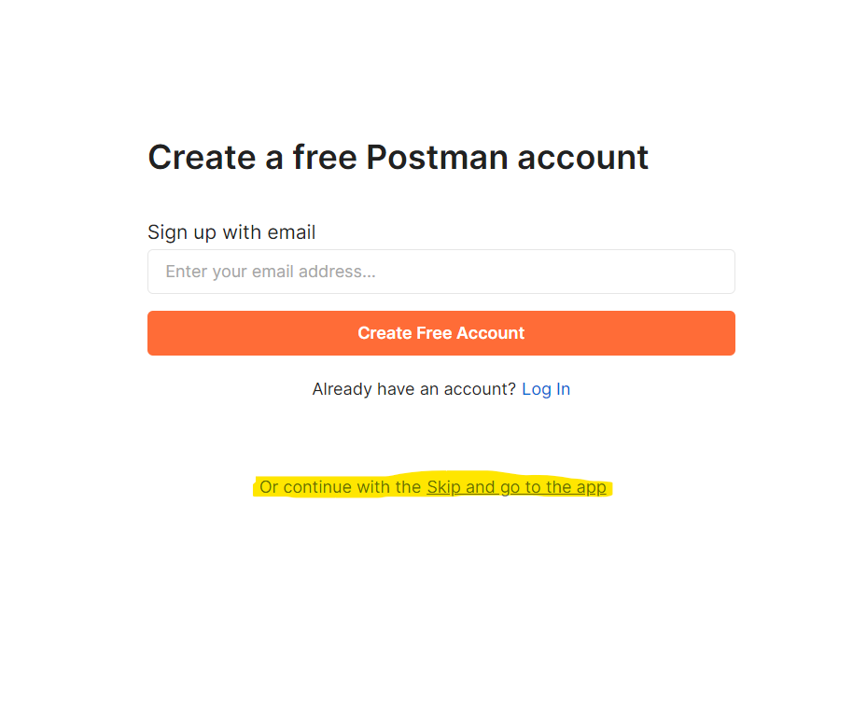

Figure 3 Create an account prompt

4. You will be asked to **create an account or sign in**. For purposes of this workshop there is no need to use extended functionality of Postman.

You can skip it and press **“Skip and go to the app**”

The following window should appear:

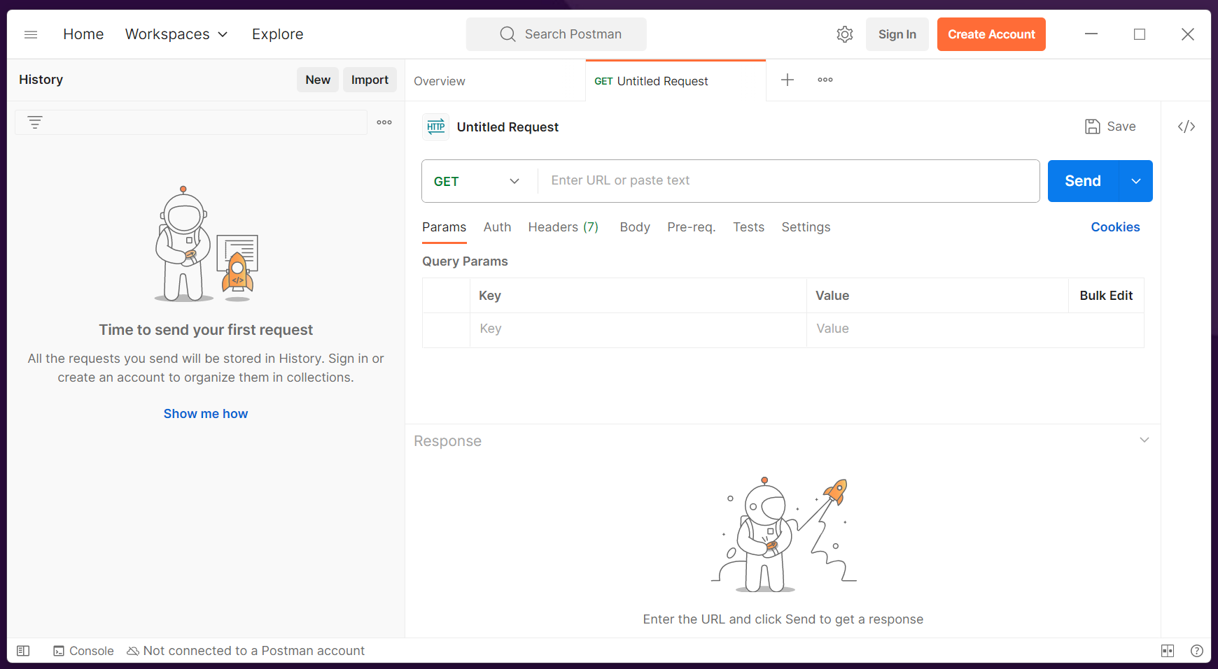

Figure 4 Postman window after installation

5. Congratulations! You are now ready to work with **Postman**!

# Check prerequisites.

## 1.1 Check Java version

1. Press “**Windows +R**”

2. In “**Run**” window please type „**cmd**” command as shown on *Figure 5*

3. Press **Enter** or click “**Ok**”.

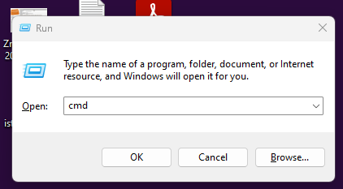

Figure 5 „Run” window with „cmd” command

Command prompt should appear on your screen.

Let’s check if you have Java installed on your computer.

4. Type “**java -version**”

5. Press “**Enter**” and wait for the response (*Figure 6*)

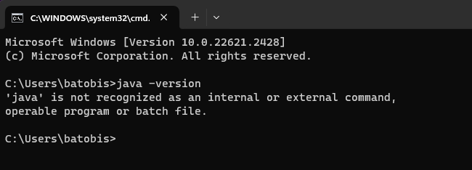

Figure 6 Command prompt response: Java not recognized

If the response is like shown in *Figure 6* or similar, you probably don’t have Java installed.

**Java** Installation paragraph in this case is obligatory.

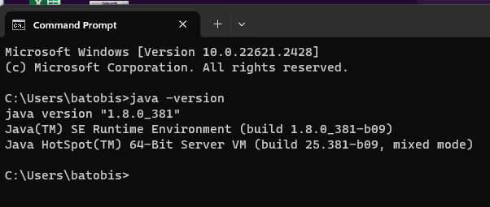

Figure 7 Command prompt response with Java 8 installed

If you receive response shown in *Figure 7*, then skip 2. paragraph (Java Installation) of this instruction. JAVA 1.8 or above is necessary. If you have got older version, please follow Java Installation paragraph.

## 1.2 Check Maven version

Now it is necessary to check if Maven is installed on your machine:

1. In command prompt type “**mvn -version**”

2. Press **Enter** and wait for the response

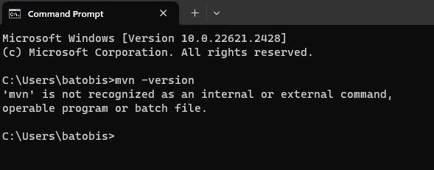

Figure 8 Command prompt response without Maven installed

If the response is like the one shown on *Figure 8* or similar, you probably don’t have Maven installed.

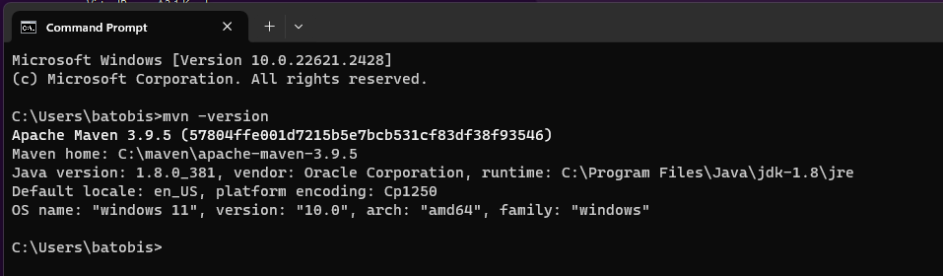

Figure 9 Command prompt response with Maven 3.9 installed

If you receive response with Maven version given *(Figure* 9), then skip 3. paragraph (Maven Installation) of this instruction.

# Java installation

To download **Java** you need to have an **Oracle account**.

If you already have one, please **sign in** and skip **2.1 Oracle registration** step from this instruction.

## 2.1 Oracle registration

1.Go to: <https://profile.oracle.com/myprofile/account/create-account.jspx>

2.Fill the form and press “**Create Account**” button *(Figure 10*)

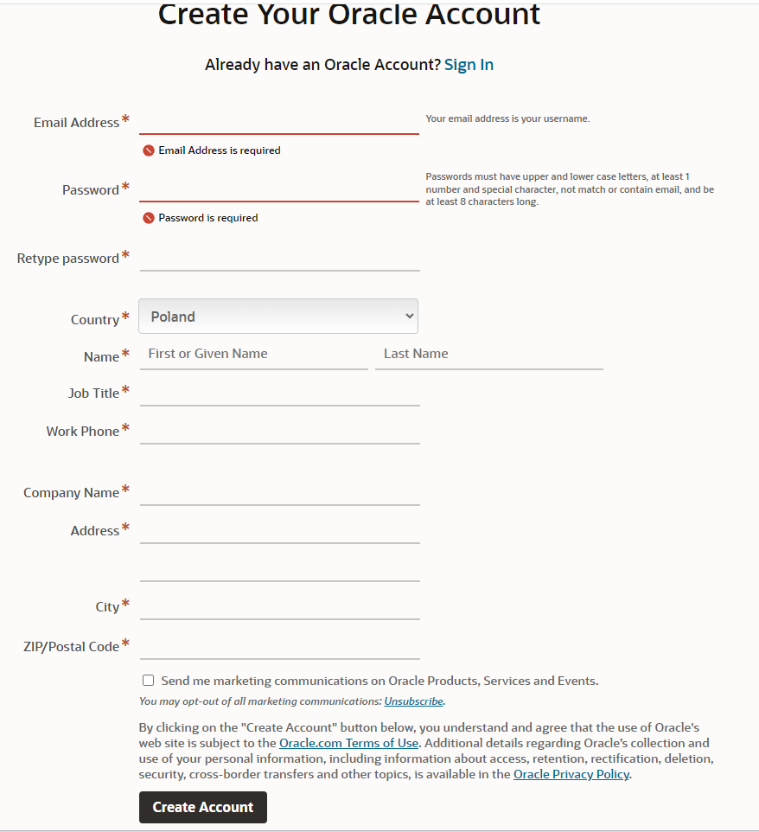

Figure 10 Oracle Account registration form

3. Prompt to check your email inbox should appear (*Figure 11*)

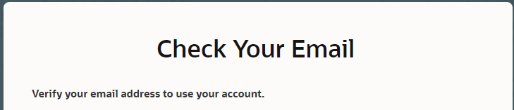

Figure 11 „Check your Email” prompt from Oracle page

4. Check your email inbox and verify your email address by clicking “**Verify Email Address**” button in received mail from Oracle (*Figure 12*)

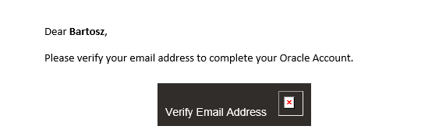

Figure 12 Example confirmation e-mail from Oracle

5**. Sign in** using created account credentials on page:

<https://login.oracle.com/mysso/signon.jsp?request_id=007>

## 2.2 Install Java

1. Open link: <https://www.oracle.com/java/technologies/javase/javase8u211-later-archive-downloads.html>

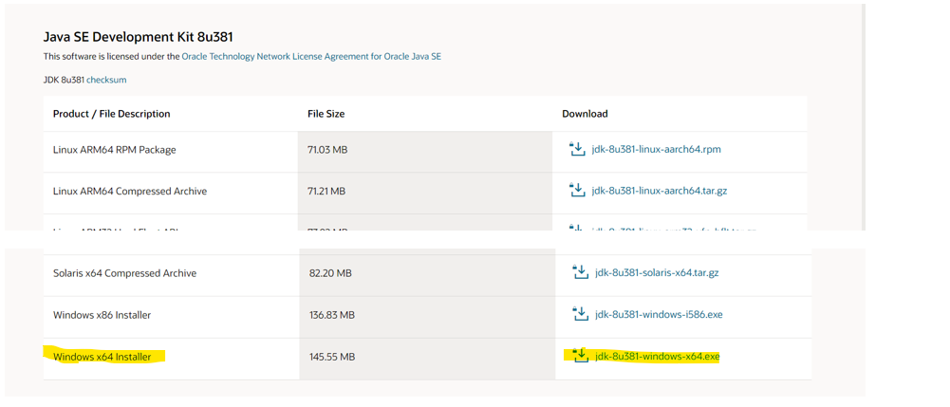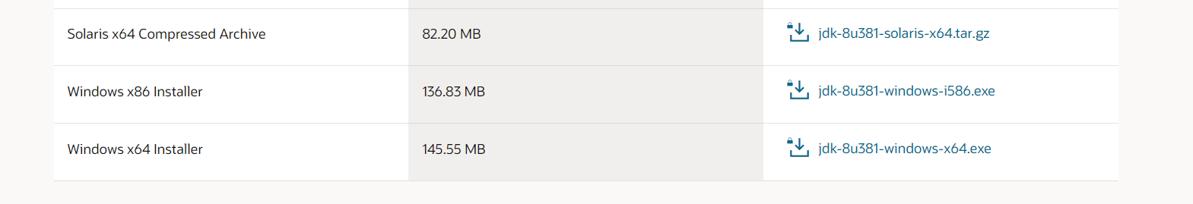

Figure 13 Java Development Kit download center

2. Select installer “**Windows x64 installer**”. (*Figure 13*)

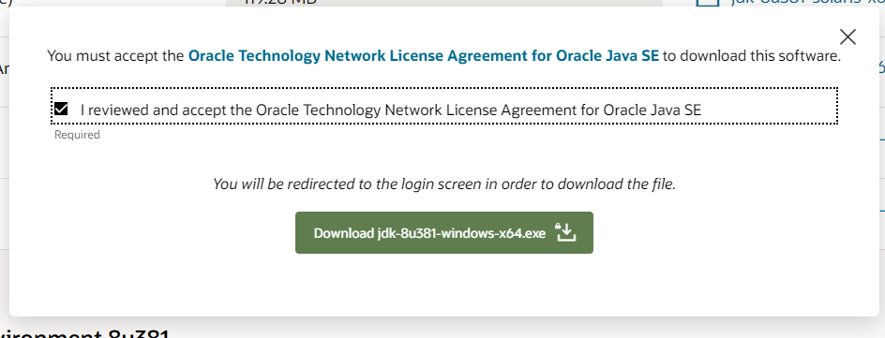

Figure 14 Download prompt visible after choosing Java version

3. Download file by pressing green **“Download**…” button (*Figure 14*).

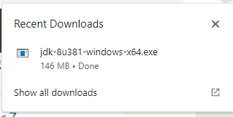

Figure 15 Downloaded JDK installer file

4. Open downloaded file (*Figure 15*).

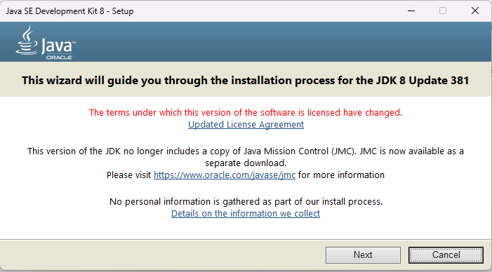

Figure 16 Welcome window of JDK Installer

Window shown on *Figure 16* should appear.

5. Click “**Next**” (*Figure 16*)

For our purposes we don’t need Public JRE

6. Select option shown on *Figure 17* and press **“Next**” (*Figure 17*)

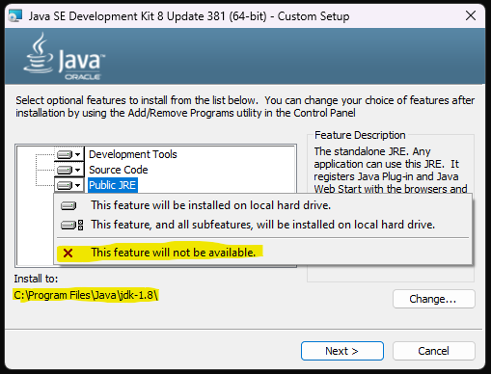

Figure 17 JDK installer „Custom Setup” window

7. Remember the path to installation folder (“**Install to**:” *Figure 17*).

It is necessary for further steps of this instruction.

8. Press “**Next**” button. Wait until Java installation will be competed.

Following window should appear:

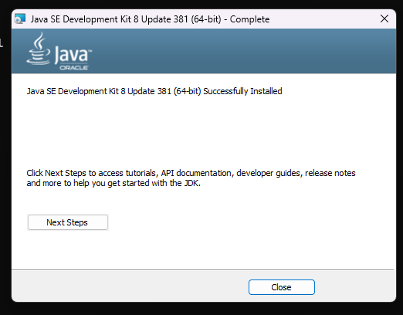

Figure 18 JDK installation guide

Java is successfully installed.

9. Press “**Close”**.

## 2.3 Environment Variables setup

1. Open **Search** window.

2.Type “**Edit environment variables for your account**”

3.Press “**Enter”**. The following window should appear:

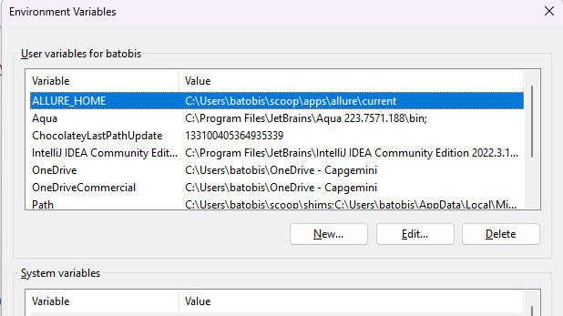

Figure 19 Environment Variables window

4. In the **Environment Variables** window, under the “**User variables for…**” section, click “**New**.” (*Figure 19)*

5. For the “**Variable name**,” enter JAVA_HOME.

6. For the “**Variable value**,” enter the path to your JDK installation directory. For example, C:\Program Files\Java\jdk-x.x.x (replace x.x.x with your actual version number). (*Figure 20*)

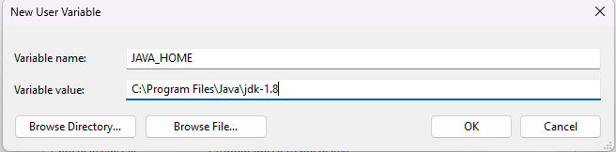

Figure 20 New User Variable window

7. Click “**OK**” to save the variable. (Figure 20)

Next, you need to add the bin directory of your JDK installation to the PATH environment variable.

8. Find the “**Path**” variable under the “**User variables for…**” section and select it. (*Figure 19*)

9. Click “**Edit.**” (*Figure 19*)

10. Click “**New**” and then add the path to the bin directory inside your JDK installation directory. For example, **C:\Program Files\Java\jdk-x.x.x\bin**. (*Figure 21*)

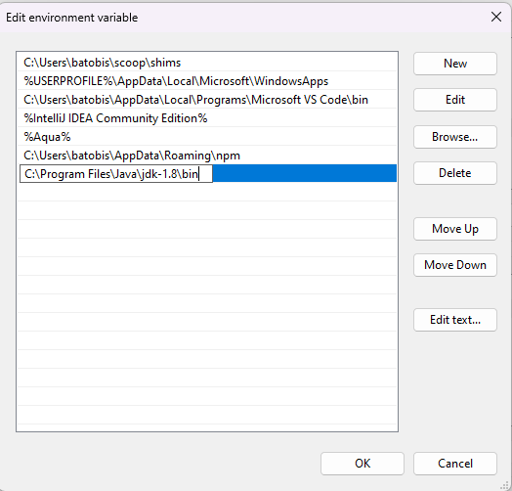

Figure 21 Edit environment variable window

11. Click “**OK**” to save the changes

12.To verify that you’ve set up the environment variables correctly, open a new Command Prompt window and run the following command: “**java -version**”

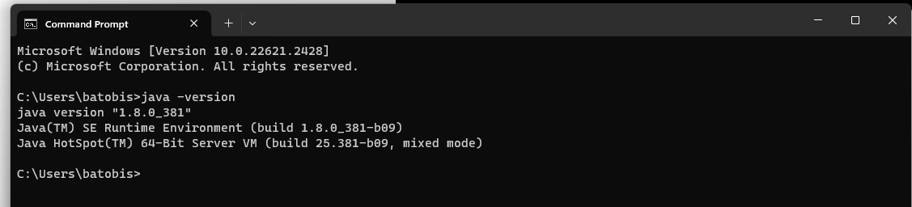

Figure 22 Command prompt successful response

Now, you have successfully set up the Java environment variables. You can start developing and running Java applications on your system.

**IMPORTANT**: Before checking the installation make sure that you’ve closed the “Environment Variables” window and also restarted command prompt.

# Maven installation

## 3.1 Download and extract files

1. Go to <https://maven.apache.org/download.cgi> page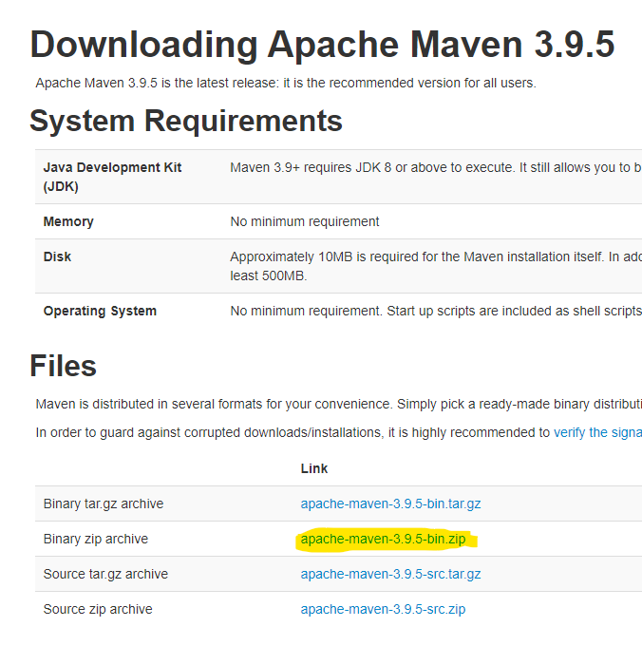

Figure 23 Apache Maven download page

2. Select “**Binary zip archive**” link and download it. (*Figure 23*)

3. Open **File Explorer**, go to “**C:**” and create new “**maven**” folder. (*Figure 24*)

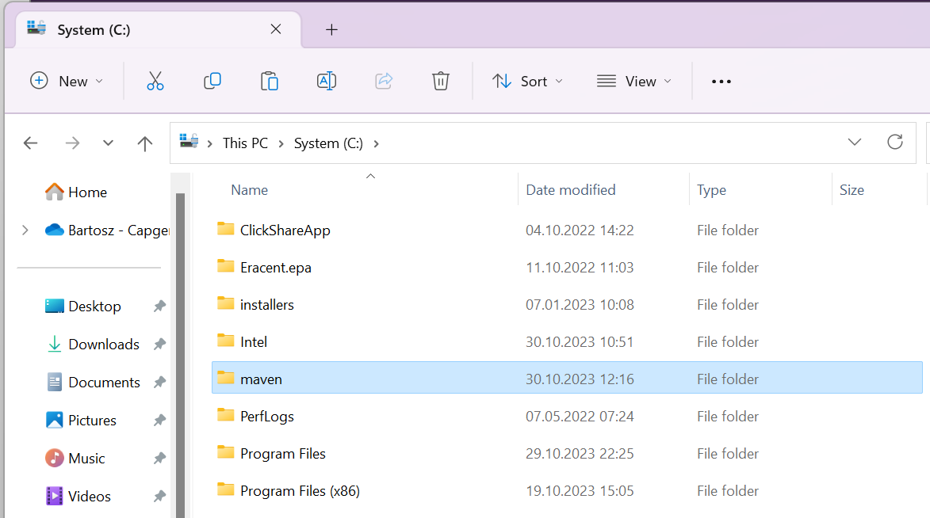

Figure 24 Newly created „maven” folder

4.Copy downloaded zip file and paste it in previously created “**maven**” folder.

5**. Right-click** on zip file and press “**Extract All…**” (*Figure 25*)

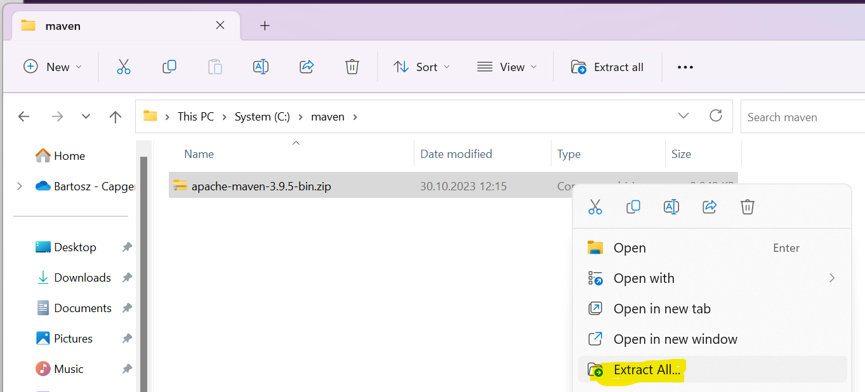

Figure 25 „Extract All...” command

6. Set proper destination for file extraction **(“C:\maven”**) and click “**Extract**” (*Figure 26*)

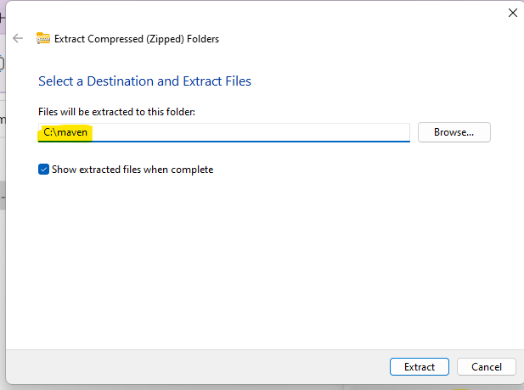

Figure 26 „Select a Destination and Extract Files” window

## 3.2 Environment Variables setup

## Similar to Java, we also have to edit Environment Variables.

1. Open **Search** window.

2. Type “**Edit environment variables for your account**” and press **Enter**.

The following window should open (*Figure 27*):

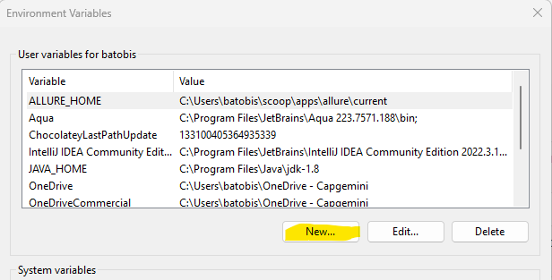

Figure 27 Environment Variables window

3. Click “**New**”.

4. Set “**Variable name**” to “**MAVEN_HOME**”.

5. In “**Variable value**” provide path to your maven folder. (*Figure 28*)

6. Press **OK**.

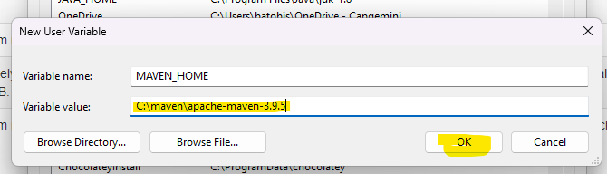

Figure 28 „New User Variable” window

New entry “**MAVEN_HOME**” should appear in “**Environment Variables**” window (*Figure 29*)

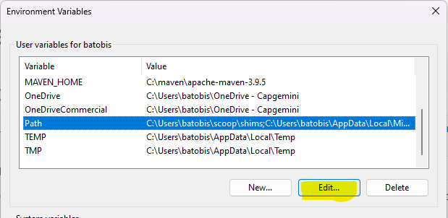

Figure 29 Selected “Path” variable

7. Select “**Path**” entry and click “**Edit…**” (*Figure 29*). Edit environment variable window should appear. (*Figure 30*)

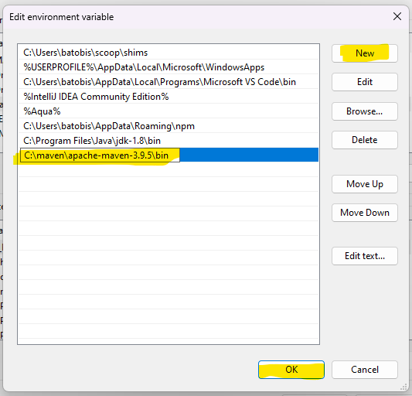

Figure 30 „Edit environment variable” window

8. Press **New**

9. Provide path to your maven subfolder “**bin**” (Just add **“\bin**” to maven folder path from previous step). (*Figure 30*)

10. Press “**OK**” and close **Environment variables** window.

11. Open command prompt

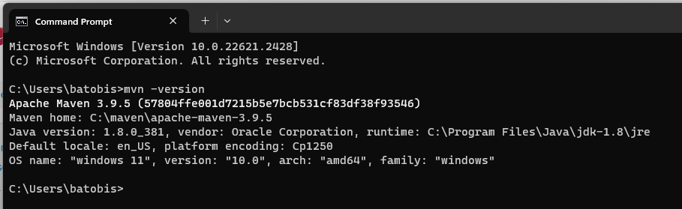

Figure 31 Command prompt response for “mvn -version” command after installation

12.Type “**mvn -version**” and press **Enter**. . (*Figure 31*)

The information about installed maven should be provided as on *Figure 31*

You successfully installed **Maven** on your computer.

# Intellij IDEA installation

1. Go to: <https://www.jetbrains.com/idea/download/?section=windows#section=windows>

2. Download installer for **Intellij IDEA Community Edition***(Figure 32):*

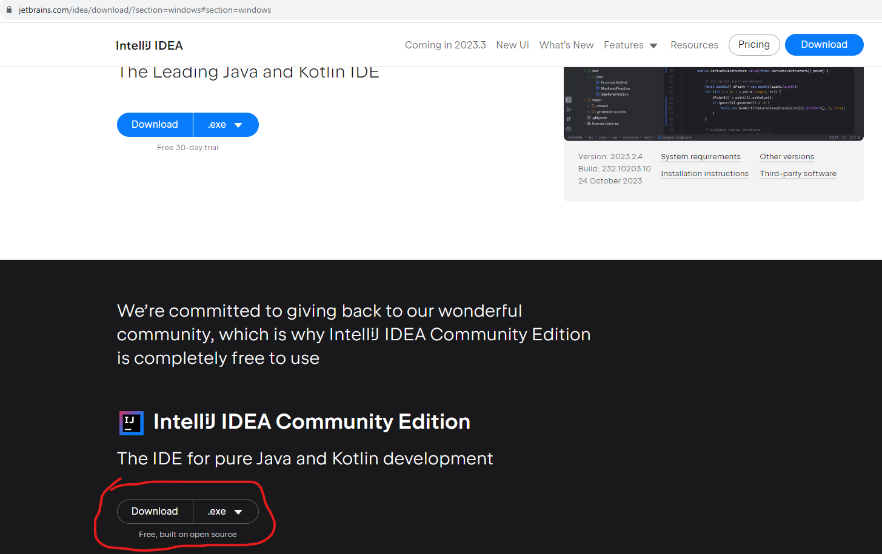

Figure 32 Intellij IDEA download page

**NOTE**: For purpose of this workshop Ultimate features are not needed, but if you want, you can download Intellij IDEA Ultimate, it is free trial for 30 days. Then you’ll need license key to use it.

3. Open downloaded file (*Figure 33*)

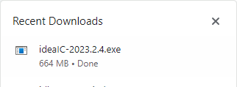

Figure 33 Downloaded Intellij IDEA installer

4. Proceed with installation by clicking “**Next**” (*Figure 34*):

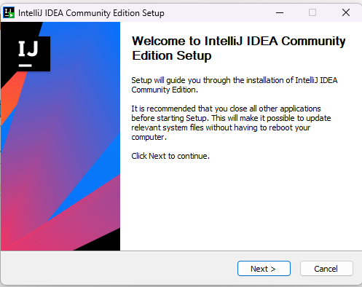

Figure 34 Intellij IDEA installer Welcome window

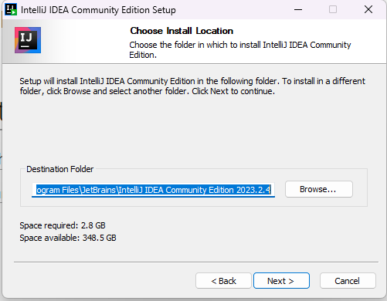

Figure 35 „Choose Install Location” window

5. Click “**Next**” on “**Choose Install Location**” window (*Figure 35*).

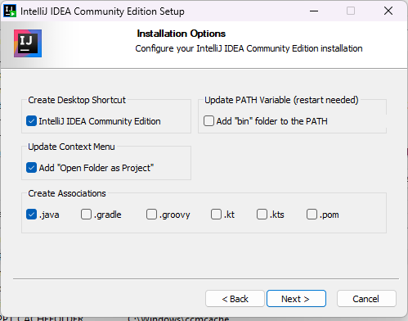

Figure 36 „Installation Options” window

6. Select “**Installation Options**” (all fields are optional) (*Figure 36*)

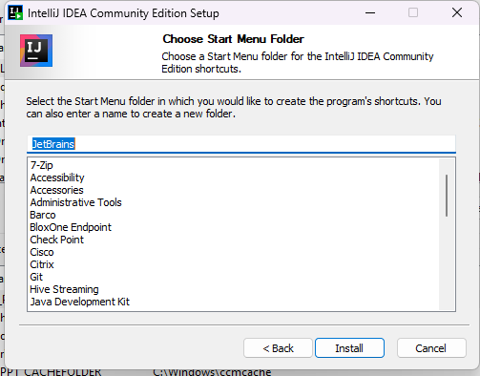

Figure 37 „Choose Start Menu Folder” window

7. Press “**Install**” button. (Figure 37)

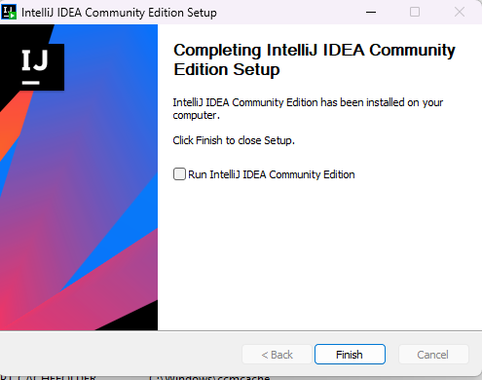

Figure 38 Intellij IDEA installation completed window

8. Press **“Finish**”. (*Figure 38*)

You successfully installed Intellij IDEA on your computer.

# Download Project

1. Go to <https://github.com/bartroll/rest-assured-workshop>

2. Press „**Code**” button. And then

3. Select “**Download ZIP**” option. (*Figure 39)*

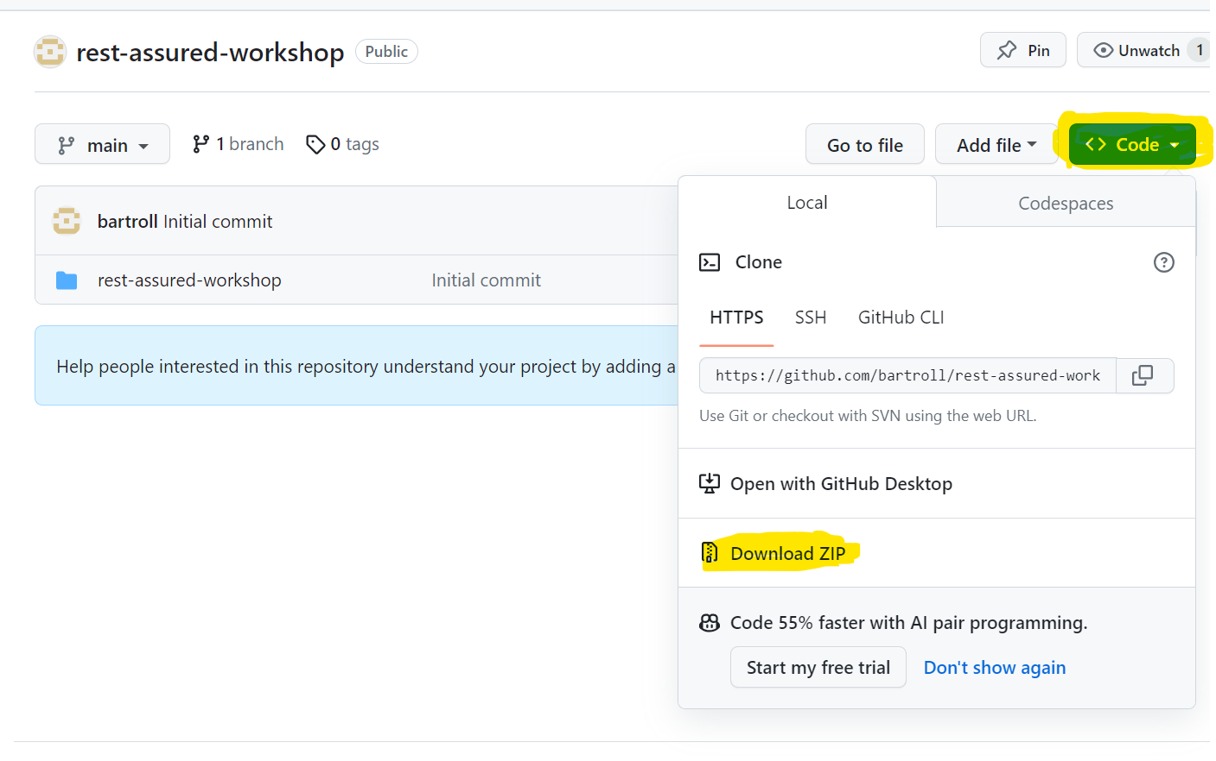

Figure 39 Github repository window

Zip file with initial project should be downloaded. (*Figure 40*)

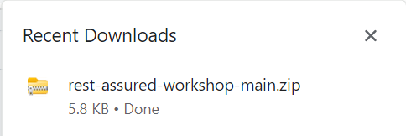

Figure 40 Downloaded “rest-assured-workshop” file

4. Extract downloaded zip file in desired location.

Congratulations! You’re ready to participate in workshop 😊

# (Workshop) Issues with building project

IMPORTANT: Instructions in this paragraph are provided in case of issues with building project during the workshop. Please do not follow it before the workshop. Thank you!

1. Check and remember your java version.
2. In Intellij: File->Project Structure:
3. 